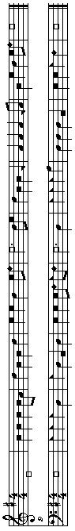JOIN US FOR

SHAPE-NOTE SINGING

FROM

THE SACRED HARP

1991 REVISION

THE SECOND MONDAY OF EVERY MONTH 7:45pm-10pm
(Short teaching session at 7:45pm, followed by group singing)

DATES through AUGUST 2016

SEPTEMBER 14 MARCH 14
OCTOBER 12 APRIL 11
NOVEMBER 9 MAY 9
DECEMBER 14 JUNE 13
JANUARY 11 JULY 11
FEBRUARY 8 AUGUST 8

THE MEETING HOUSE
ANDOVER NEWTON THEOLOGICAL SCHOOL
210 HERRICK ROAD
NEWTON CENTRE, MASSACHUSETTS

DIRECTIONS AND MAP ON REVERSE

FOR MORE INFORMATION:
617-923-6044
781-648-1009

www.norumbegaharmony.org

SPONSORED BY:
NORUMBEGA HARMONY
ANDOVER NEWTON THEOLOGICAL SCHOOL
SHAPE-NOTE SINGERS OF EASTERN MASSACHUSETTS
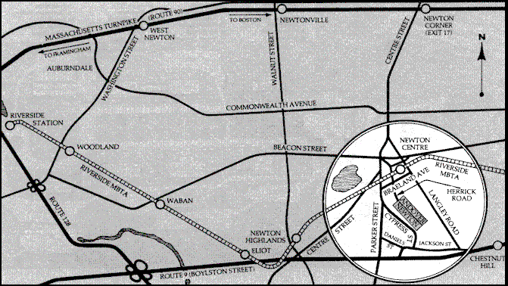
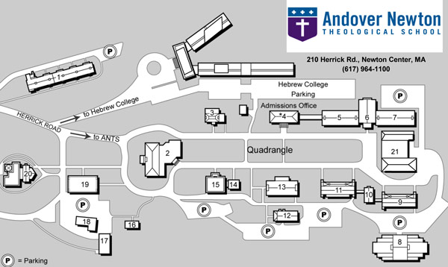
By car:

Recommended route when coming from north, south, or west:
From I-95 (also known as Route 128): Take Exit 20A (Route 9) east toward Boston. Proceed 2.1 miles on Route 9 to the Parker Street exit. Turn left (north) onto Parker Street at the end of the exit ramp and proceed for 0.6 mile. Just before reaching the bridge over the MBTA trolley tracks and the Newton Centre business district, turn right onto Braeland Avenue. Then take the first right onto Herrick Road and follow the signs up the hill to the campus.
By rapid transit:

From the MBTA trolley: Take the Green Line, Riverside Branch (D train) to Newton Centre. As you get off an outbound car, Herrick Road is on the left. Proceed on Herrick Road up the hill to the campus—10-15 minute walk. It takes approximately 30 minutes on the T from downtown Boston to Newton Centre. There is a taxi stand at the T stop.
The Meeting House is building #12, at the bottom center of the map. Occasionally we must use an alternate location: most often we move to Wilson Chapel (#21) or to the Peck Conference Room (#5, downstairs).

Please call or send email to nh_2dmonday@yahoo.com in order to receive reminders and notifications of location changes and weather-related cancellations.

